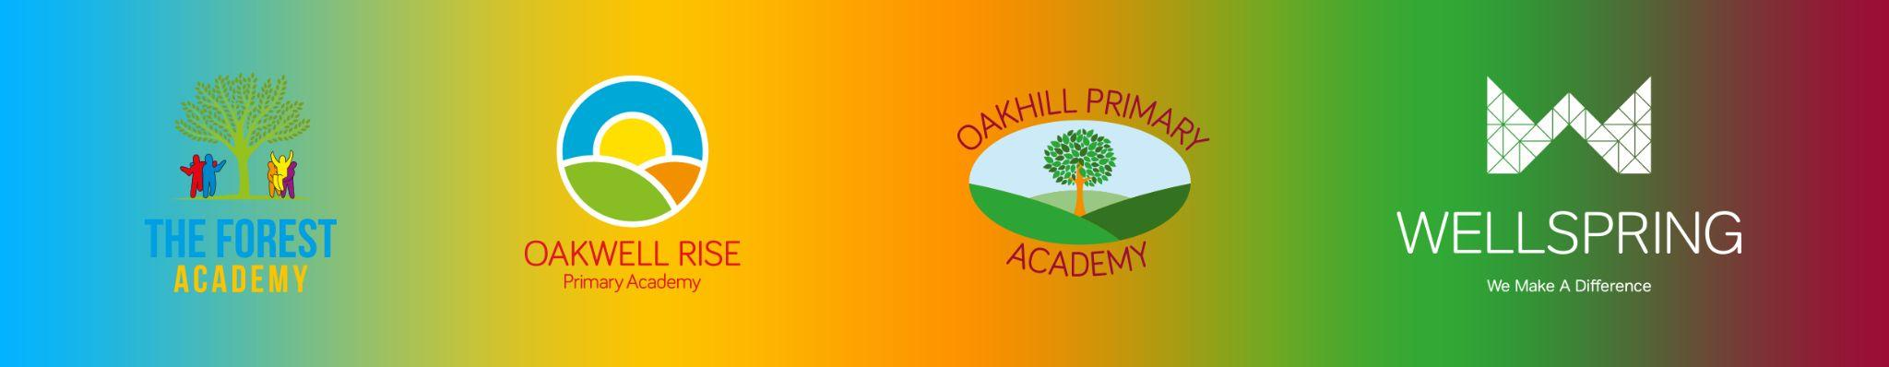

**BARNSLEY PRIMARY PARTNERSHIP GOVERNING BODY STATUTORY TRAINING AND DECLARATION OF INTERESTS 2024/25**

All governors have a statutory responsibility to read and understand Keeping Children Safe in Education, and declare a wide range of interests on an annual basis. Our Governors also complete Cyber Security and Prevent duty training on a regular basis. The table below indicates when this was last completed.

|  |  |  |  |  |  |
| --- | --- | --- | --- | --- | --- |
| **Governor Name** | **Declaration of Interests** | **Keeping Children Safe In Education** | **Prevent Refresher Training** | **Cyber Security Training** | **Declared interests** |
| Ken Mosley | 05.11.2024 | 05.11.2024 | 05.11.2024 | 05.11.2024 | N/A |
| Mick Neal ( Chair) | 22.10.2024 | 22.10.2024 | 22.10.2024 | 22.10.2024 | * Barnsley Foodbank Partnership (2012 to date) * The Methodist Church Barnsley South (2016 to date) * Keresforth Primary School Barnsley since 2012 |
| Michala Wild | 05.11.2024 | 05.11.2024 | 05.11.2024 | 05.11.2024 | N/A |
| Dayo Oladiti | 25.11.2024 | 25.11.2024 | 25.11.2024 | 25.11.2024 | Astrea Academy Trust - Hatfield Primary Academy LGC.  Date: September 2024  Sheffield Hallam University/Planning and Initiatives Officer |
| Jane Kirkham | PENDING | PENDING | PENDING | PENDING | PENDING |
| Craig Aubrey (Vice Chair) | 21.10.2024 | 21.10.2024 | 21.10.2024 | 21.10.2024 | BMBC - community development officer  Wife works at Wellspring Academy Trust |
| Ella Copping | 04.11.2024 | 04.11.2024 | 04.11.2024 | 04.11.2024 | Wellspring, Class Teacher at The Forest Academy |
| Laura Barraclough | 04.10.2024 | 04.10.2024 | 04.10.2024 | 04.10.2024 | Employed by Wellspring Academy Trust |
| Jessica Jenkins | 05.11.2024 | 05.11.2024 | 05.11.2024 | 05.11.2024 | Sister works in a company which the Wellspring Academy Trust which have used for private occupational therapy work, which was approved by the previous EP. |
| Katie Pierce | 02/01/2025 | 02/01/2025 | 02/01/2025 | 02/01/2025 | N/A |
| Natalie Hardman | 06.11.2024 | 06.11.2024 | 06.11.2024 | 06.11.2024 | N/A |
| Rebecca Barham | 12.03.2025 | 12.03.2025 | 12.03.2025 | 12.03.2025 | Positive Regard Consultant (Wellspring Academy Trust) - Current role commenced March 2024 |
| Eileen Sanderson | 16.10.2024 | 16.10.2024 | 16.10.2024 | 16.10.2024 | * Serve as a volunteer on the Board of Directors of the Forge Community Partnership * Elsecar Community Nursery child care and education since May 2016 |
| Governors who have left the LGB in the last 12 months: | | | | | |
|
| **Governor Name** | **Left the LGB** | | | | |
| Fr Blair Radford | June 2024 | | | | |
| Michael Sanderson | February 2025 | | | | |
| Fr Paul Cartwright | February 2025 | | | | |
| Scott McHale | February 2025 | | | | |
|  |  | | | | |
|  |  | | | | |
|  | | | | | |