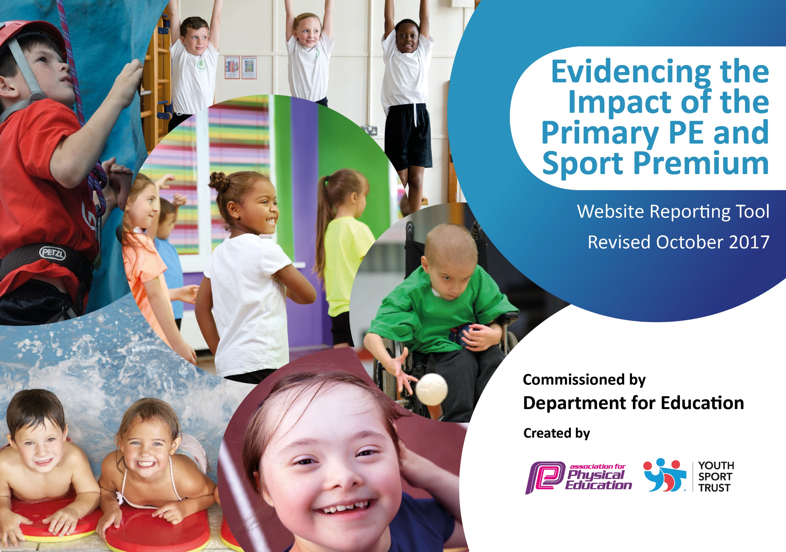

Schools must use the funding to make **additional and sustainable** improvements to the quality of PE and sport they offer. This means that you should use the Primary PE and Sport Premium to:

* develop or add to the PE and sport activities that your school already offers
* 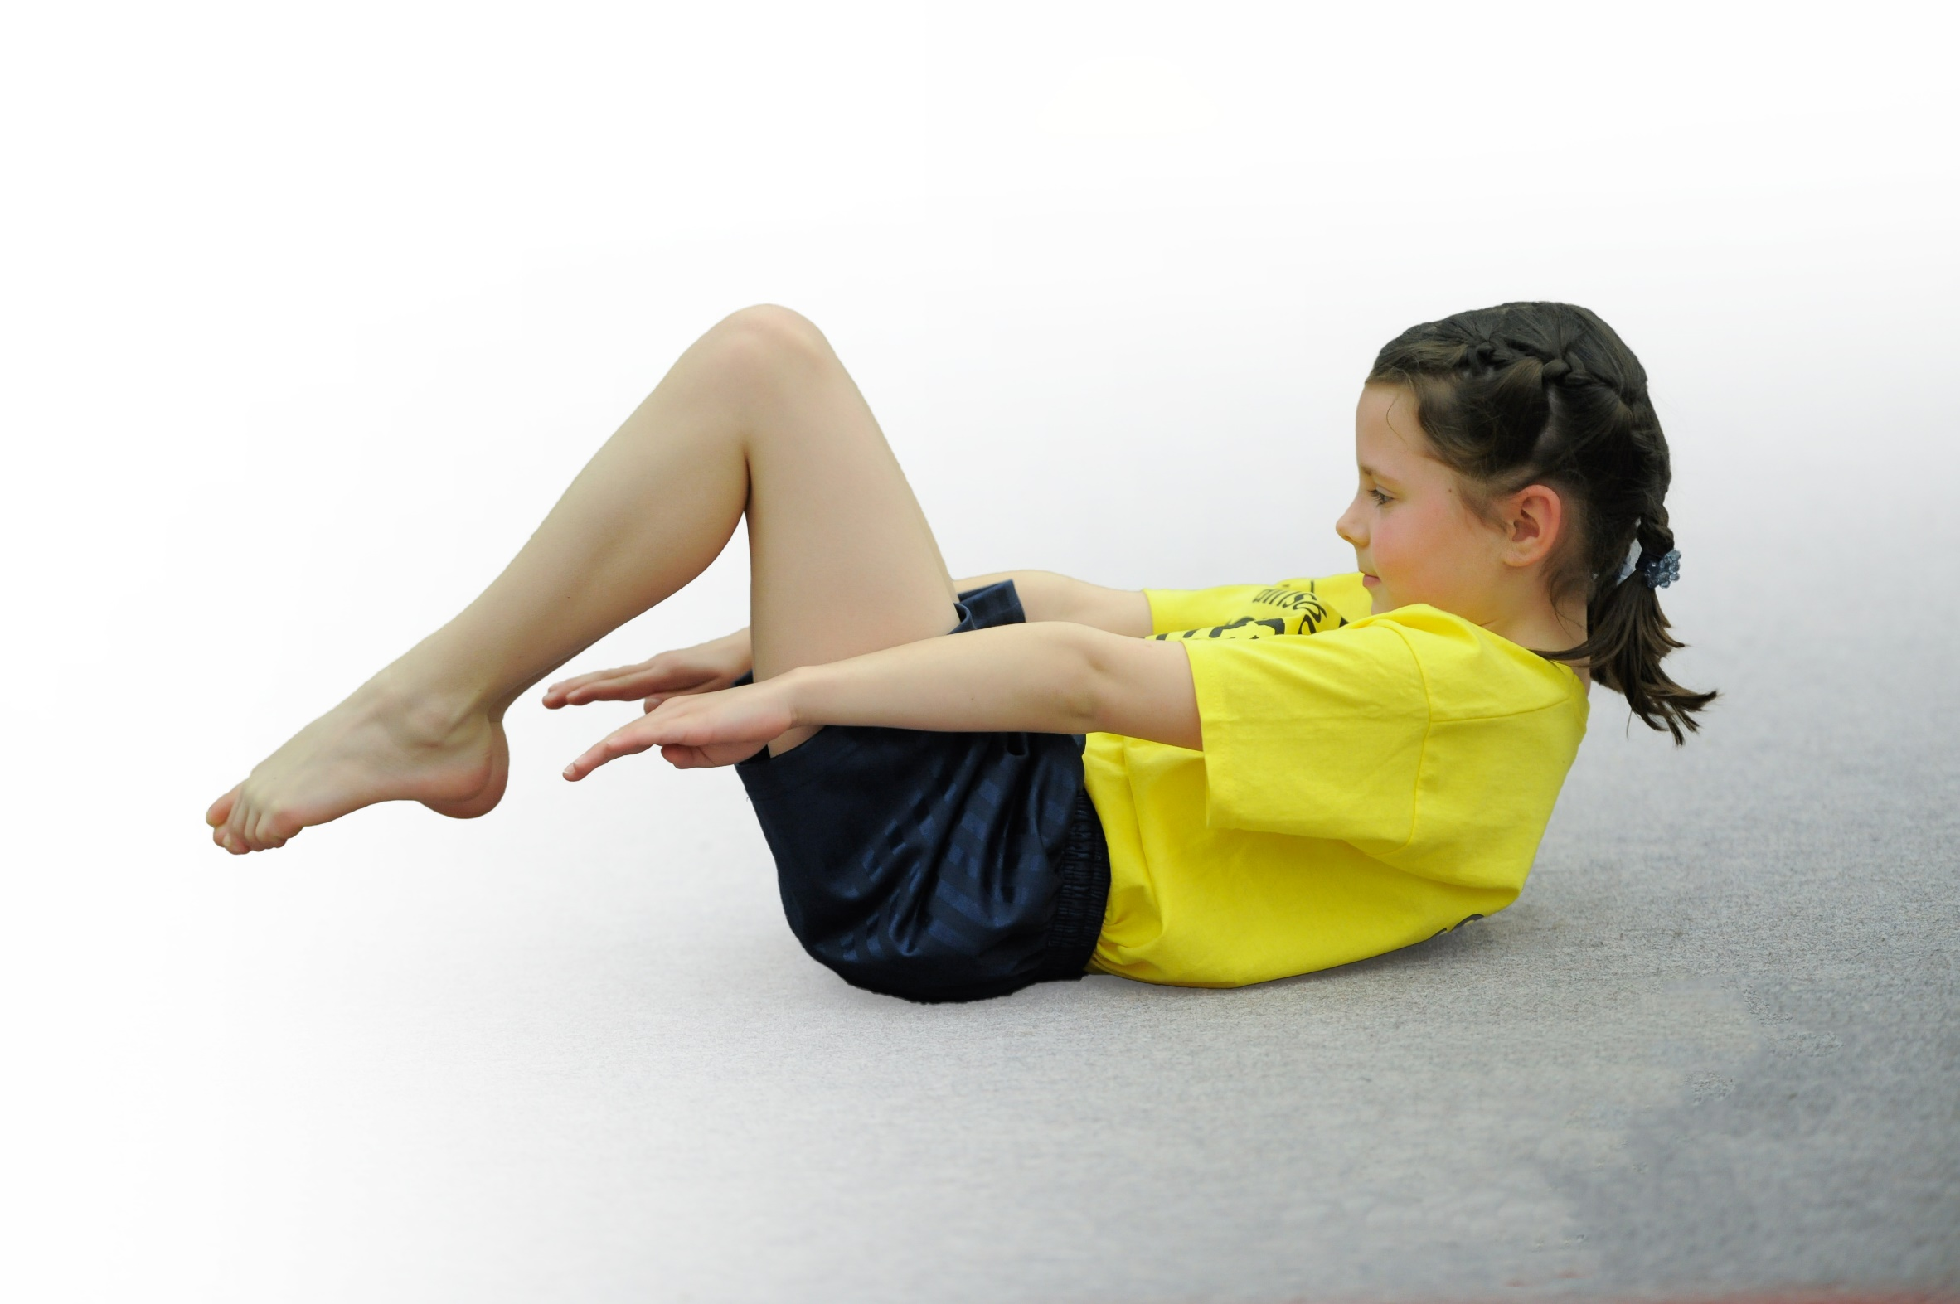build capacity and capability within the school to ensure that improvements made now will benefit pupils joining the school in future years

Please visit [gov.uk](https://www.gov.uk/guidance/pe-and-sport-premium-for-primary-schools) for the revised DfE guidance including the 5 key indicators across which schools should demonstrate an improvement. This document will help you to review your provision and to report your spend. DfE encourages schools to use this template as an effective way of meeting the reporting requirements of the Primary PE and Sport Premium.

We recommend you start by reflecting on the impact of current provision and reviewing the previous spend.

Under the [Ofsted Schools Inspection Framework](https://www.gov.uk/government/publications/school-inspection-handbook-from-september-2015), inspectors will assess how effectively leaders use

the Primary PE and Sport Premium and measure its impact on outcomes for pupils, and how effectively [governors](https://www.gov.uk/government/publications/governance-handbook) hold them to account

for this.

Schools are required to [publish details](https://www.gov.uk/guidance/what-maintained-schools-must-publish-online#pe-and-sport-premium-for-primary-schools) of how they spend this funding as well as on the impact it has on pupils’ PE

and sport participation and attainment.

We recommend regularly updating the table and

publishing it on your website as evidence

of your ongoing review into how you are using the money

to secure maximum, sustainable impact. To see an example of how to complete the table please click [HERE](http://www.afpe.org.uk/physical-education/wp-content/uploads/Template-Exemplification.pdf).

Support for review and reflection - considering the 5 key indicators from DfE, what development needs are a priority for your setting and your students now and why? Use the space below to reflect on previous spend, identify current need and priorities for the future.

|  |  |
| --- | --- |
| Key achievements to date: | Areas for further improvement and baseline evidence of need: |
| * Number of additional lunch time sessions increased * Number of inter-school sporting opportunities increased * Audit of all PE equipment and resources and extra resource provision * PE delivered by Primary Future Stars qualified lead sports coaches * Number of holiday clubs increased * Number of after school clubs increased * End of year dance festival * Sports day linked to external event – World Cup | * Increase number of competitions entered each year * Increase number of extra-curricular activity clubs offered * Increase parental involvement in our PE & Sport program * Children meeting the expected standard in PE to increased * Standards in swimming to increased * Develop Health and Fitness theory program and curriculum development of Health and Well-being lessons linked to science * Introduce the playmakers qualification * Increase celebration of sporting successes as an item in our end of half term celebration assemblies * Raise aspirations from heroes/ events * Professional development opportunities for staff to increase * Seek to gain Healthy schools award |

|  |  |
| --- | --- |
| Meeting national curriculum requirements for swimming and water safety | Please complete all of the below: |
| What percentage of your Year 6 pupils could swim competently, confidently and proficiently over a distance of at least 25 metres when they left your primary school at the end of last academic year? | 67% (26 Children) |
| What percentage of your Year 6 pupils could use a range of strokes effectively [for example, front crawl, backstroke and breaststroke] when they left your primary school at the end of last academic year? | 67% (26 Children) |
| What percentage of your Year 6 pupils could perform safe self-rescue in different water-based situations when they left your primary school at the end of last academic year? | 67% (26 Children) |
| Schools can choose to use the Primary PE and Sport Premium to provide additional provision for swimming but this must be for activity **over and above** the national curriculum requirements. Have you used it in this way? | No |
|  | |

**Action Plan and Budget Tracking**

Capture your intended annual spend against the 5 key indicators. Clarify the success criteria and evidence of impact that you intend to measure to evaluate for students today and for the future.

|  |  |  |  |  |
| --- | --- | --- | --- | --- |
| **Academic Year:** 2017/18 | **Total fund allocated:** £18450  **+ £5450 Budget**  **+ £5760 Swimming** | **Date Updated: June 2018** | |  |
| **Key indicator 1:** The engagement of all pupils in regular physical activity – Chief Medical Officer guidelines recommend that primary school children undertake at least 30 minutes of physical activity a day in school | | | | Percentage of total allocation: |
| 51 % |
| School focus with clarity on intended **impact on pupils**: | Actions to achieve: | Funding allocated: £15200 | Evidence and impact: | Sustainability and suggested next steps: |
| 1. All pupils have 2 sessions of high quality PE per week (Y1-Y6) 2. Foundation Stage children to have regular PE sessions as part of the ‘Moving and Handling’ objective 3. Future Stars delivery of daily active lunchtime program 4. Extensive extra-curricular clubs after school including all areas of the curriculum | * Whole school PE & Sport timetable in place * Links established with Primary Future Stars * Active lunch time program in place * Range of play equipment available for playtime and lunch times. | £9500 PE delivery  £5700  Lunch time provision | * Children have a positive attitude to PE seen in VOTL * Children meeting expected standard in PE has increased * More children are meeting the ELG for moving and handling * Over 50% of children attend extra-curricular clubs | Further development in lunch time provision and creating further opportunities through provision and location (Use of KS1 area) |
| **Key indicator 2:** The profile of PE and sport being raised across the school as a tool for whole school improvement | | | | Percentage of total allocation: |
| 3% |
| School focus with clarity on intended **impact on pupils**: | Actions to achieve: | Funding allocated: £1000 | Evidence and impact: | Sustainability and suggested next steps: |
| 1. Lead teacher for PE & Sport identified in school 2. Awards in assemblies 3. PE in newsletter 4. Purchase age appropriate equipment to support delivery and breadth of activities 5. Extra-curricular club profile raised | * Items in newsletter sent out to parents/carers * Half termly celebration assemblies held * Website updates for PE * Ensure extensive extra-curricular program * Audit and purchase of sports equipment | £30 Sports Day  £770 Resource provision  £200 Gym equipment | * Increase of children receiving awards in assemblies * Feedback from parents and children about the newsletter * Increase of children trying different activities in after-school and lunch clubs | * PE and Sport Pages in Newsletter * Specific PE page on Website * Develop external partnerships – Taekwondo, Dance, Fitness for Fun, Bike-ability * Specific PE displays in school * PE linked to Health & Well-being and Science |

|  |  |  |  |  |
| --- | --- | --- | --- | --- |
| **Key indicator 3:** Increased confidence, knowledge and skills of all staff in teaching PE and sport | | | | Percentage of total allocation: |
| 0% |
| School focus with clarity on intended  **impact on pupils**: | Actions to achieve: | Funding  allocated:NIL | Evidence and impact: | Sustainability and suggested  next steps: |
| 1. CPD sessions for all primary teaching staff by specalists 2. Links with and delivery from coaching specialists 3. Observation/CPD opportunities for delivery of PE lessons | * Staff CPD focus and delivered * Meeting to discuss & to observe practice and develop knowledge of coaching staff * Clear program and schemes to show and support activities progression (including clear timetable) | NIL | * All staff more confident in delivery seen in outcomes and QA * CPD booklets with planning and examples of good practice to support staff * RUFC QA * More accurate tracking of PE * Staff enjoyment of PE | * Continue CPD program * Maintain secondary specialism links * Make links with and ask Secondary specialists available for guidance and support |
| **Key indicator 4:** Broader experience of a range of sports and activities offered to all pupils | | | | Percentage of total allocation: |
| 44% |
| School focus with clarity on intended  **impact on pupils:** | Actions to achieve: | Funding  allocated: £12,960 | Evidence and impact: | Sustainability and suggested  next steps: |
| Additional achievements:   * All Y3 pupils experience swimming * All pupils take part in Sports Day * UKS2 opportunity to take part in Football tournament with partnership schools * Lunch time and after school opportunities for all pupils * Kwik cricket sports event for Y5/Y6 * opportunity to enroll and gain qualification in ‘Sports Leaders’ or ‘Peer supporter’ | * Timetable planning for all PE lessons, lunch times and after-school clubs * Arrange events out of school including transport * Plan to deliver Sports Leader Qualification starting in Summer 2 ready for September start. | £1500 Holiday Club  £5700 After school provision  £4260 pool hire  £1500 transport | * Children have increased confidence in water and water safety * Children have experiences of participating in high level competition * Children gain qualifications following training and experience in sports leader programs. * Children have positive experiences and memories (VOTL) | Build further inter-sporting links between Barnsley Partnership  Maintain and develop further opportunities for different experiences in curriculum and after-school time  To look at delivery of bike-ability for all pupils to compliment road safety program in Y3. |
| **Key indicator 5:** Increased participation in competitive sport | | | | Percentage of total allocation: |
| 2% |
| School focus with clarity on intended  **impact on pupils**: | Actions to achieve: | Funding  allocated: £500 | Evidence and impact: | Sustainability and suggested  next steps: |
| 1. Extra-curricular clubs to increase skill levels for competition preparation 2. Entry to all competitions/ events/ festivals in School Partnership 3. High quality focus on Sports Day | Map out all competitions and ensure coaching and training prepares pupils for competitions  Ensure all entries are received  Planning for sports day to include whole school | Entry to competitions & transport  £500 | Children experience high level sporting situations  Children meet new people/friends at competitions  Children able to demonstrate skills and have the opportunity to excel in a practical area of the curriculum  Can lead into selection for out of school clubs and opportunities | Maintain entry into local competitions  Planning for more ‘match’ opportunities (following the secondary model)  Links with clubs for talent identification. |